**Convolution Operation**

**Convolutional Neural Networks (CNNs)**

• **Definition**: A CNN is a type of neural network with an architecture that is slightly different from a traditional Artificial Neural Network (ANN). It is particularly effective with images because its working principle is based on the human visual cortex.

• **Key Layers**: CNNs are built from three main types of layers:

1. **Convolution Layer**: The focus of this class, responsible for feature extraction.

2. **Pooling Layer**: Another type of layer found in CNNs.

3. **Fully Connected Layer (Dense Layer)**: Similar to layers in ANNs, used for classification tasks.

• **High-Level Working Principle**:

◦ When an image is fed into a CNN, the initial **convolution layers** detect primitive features like **edges**.

◦ As the network goes deeper, subsequent convolution layers combine these primitive features to generate more complex features.

◦ Finally, these complex features are used by the fully connected layers for tasks like classification (e.g., identifying what the image contains).

◦ **Example (Face Detection)**: Initially, the network detects basic edges. These edges are then combined to form parts of a face like eyes, nose, and ears. These parts are then combined to form a complete face, which is then identified.

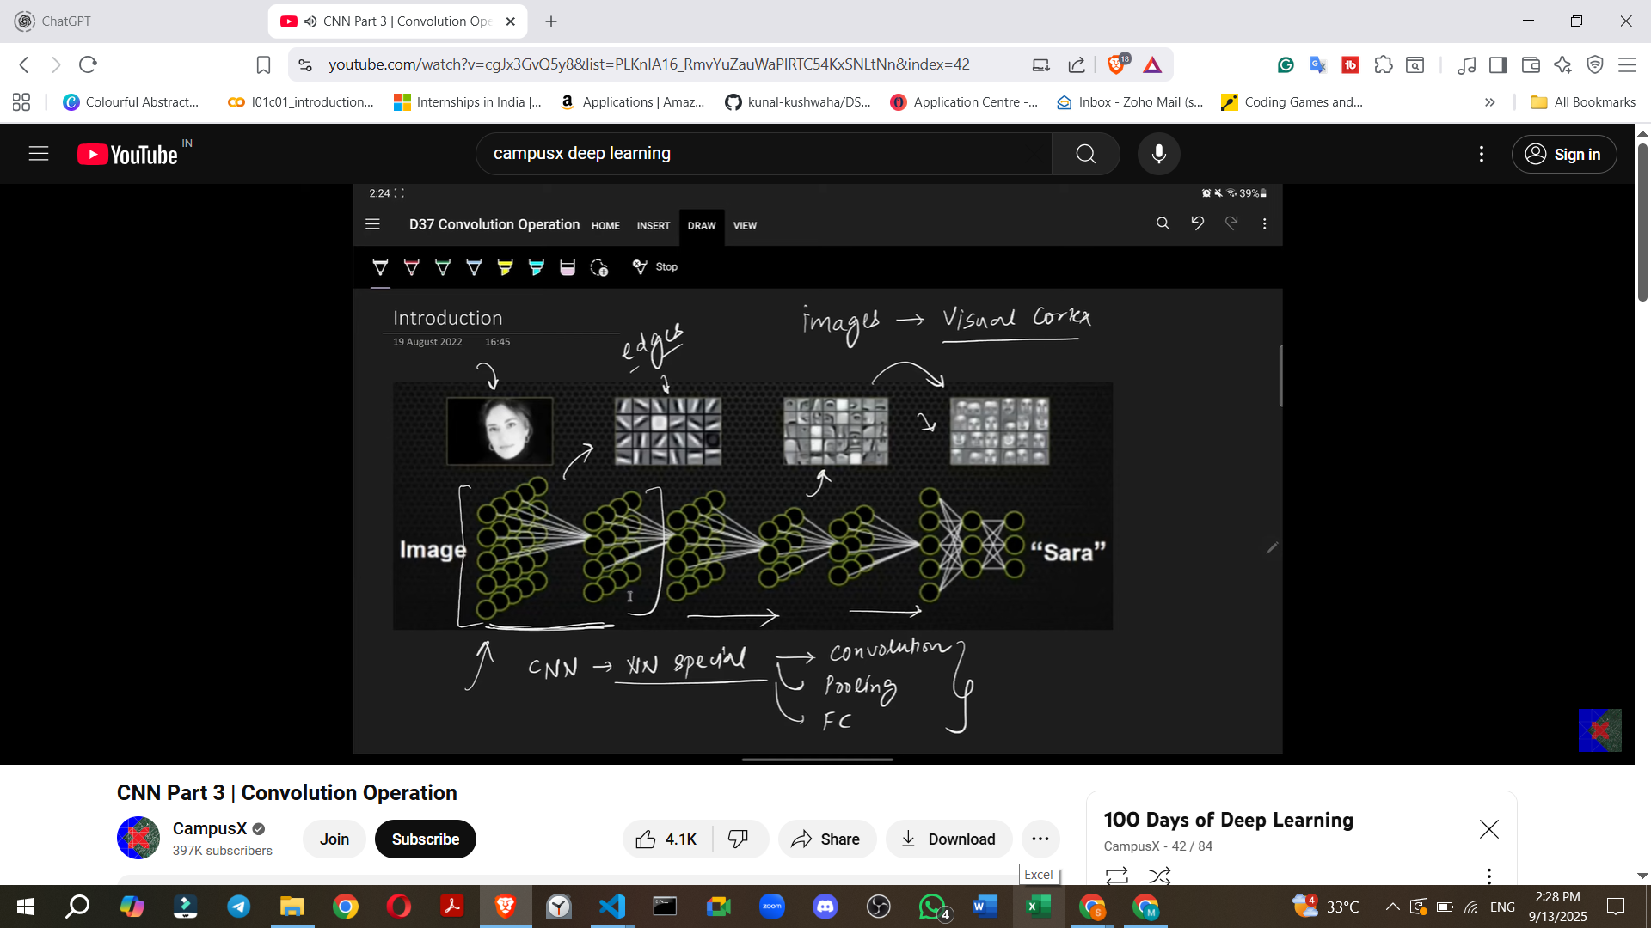

**Image Representation in Computer Memory**

Understanding how images are stored is crucial for understanding convolution.

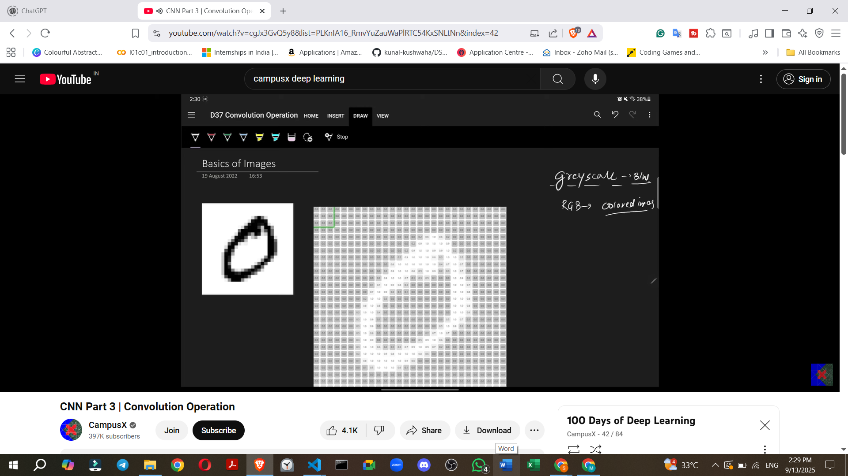

• **Grayscale Images (Black & White)**:

◦ Composed of pixels arranged in a grid.

◦ Each pixel is represented by a single number, typically between 0 and 255.

◦ **0 represents black**, and **255 represents white**. (Sometimes normalized to 0-1).

◦ Computers store and process grayscale images as 2D arrays of numbers.

◦ **Example**: An MNIST dataset image of a digit, like "0", might be a 28x28 pixel image. Each pixel in this 28x28 grid would hold a value representing its intensity (from 0 to 255).

◦ **Channels**: Grayscale images have **only one channel**.

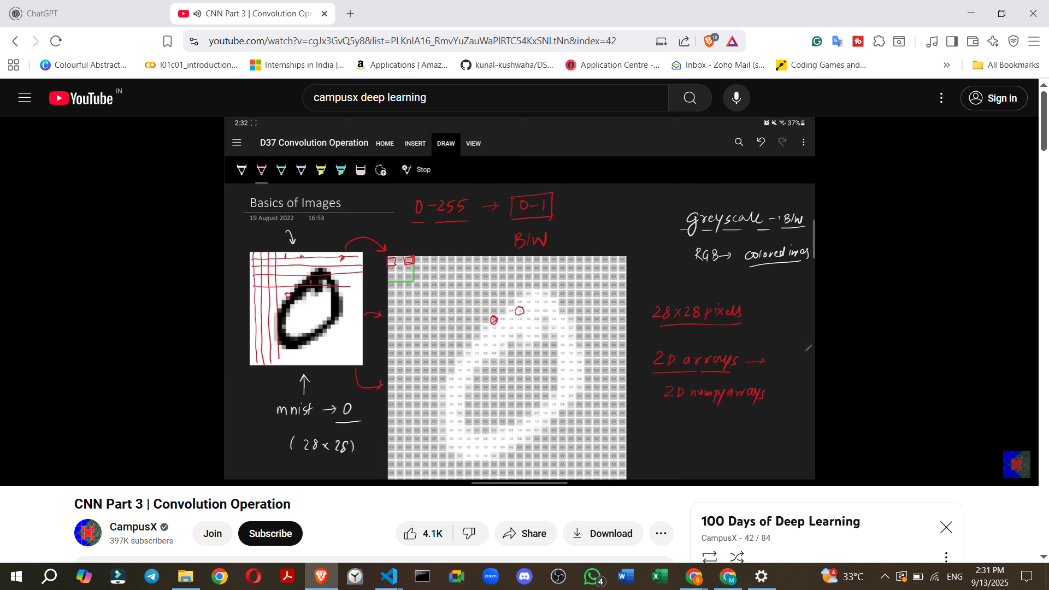

• **RGB Images (Colour Images)**:

◦ Composed of **three channels**: Red, Green, and Blue (primary colours).

◦ Each channel acts like a separate grayscale image, storing pixel intensity values between 0 and 255 for its respective colour.

◦ The combination of these three channels at each pixel location creates the final colour.

◦ **Example**: A 28x28 RGB image would effectively be a 28x28 grid for Red, another 28x28 for Green, and a third 28x28 for Blue, stacked together.



◦ **Channels**: RGB images have **three channels**.

**Convolution Operation: The Fundamental Building Block**

The convolution operation is responsible for **extracting features** from an image.

• **Edge Detection**: A common initial feature extracted by convolution layers is **edges**.

◦ **What are Edges?**: Edges represent a **change in intensity** within an image.

◦ **Example**: If an area of an image is black (low intensity) and then suddenly transitions to white (high intensity), that transition forms an edge.

◦ **Output of Edge Detection**: An edge detection operation produces an image where the detected edges are highlighted. For example, a vertical edge detection would highlight all vertical lines in the image.

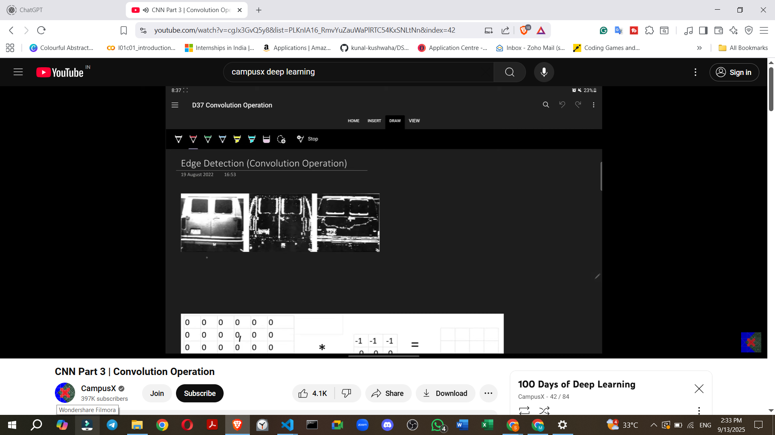

• **How Convolution Works (Step-by-Step Example)**:

1. **Input**: A small, low-resolution 6x6 grayscale image.

▪ The top three rows are black (pixel values 0), and the bottom three rows are white (pixel values 255). This creates a horizontal edge in the middle.



2. **Filter (Kernel)**: A small matrix of numbers, typically 3x3, used to detect specific features.

▪ **Example (Horizontal Edge Detector Filter)**:

▪ This specific filter is designed to detect horizontal edges.



3. **Feature Map**: The output of the convolution operation, representing the detected features.



<https://deeplizard.com/resource/pavq7noze2>

• **The Process**:

◦ The filter is placed over a section of the input image, starting from the top-left.

◦ **Element-wise Multiplication**: Each number in the filter is multiplied by the corresponding pixel value in the image section it covers.

◦ **Summation**: All the results from the element-wise multiplications are added together to produce a single number. This number becomes one pixel in the **feature map**.

◦ **Sliding the Filter**: The filter then slides **one step to the right** (or a defined stride). The process of multiplication and summation is repeated.

◦ Once the filter has covered all horizontal positions in a row, it moves **down one row** and repeats the process.

• **Detailed Calculation for the 6x6 image and 3x3 Horizontal Edge Detector**:

◦ **First Row of Feature Map**:

▪ Placing the filter over the top-left 3x3 section (all 0s): (-1*0) + (-1*0) + (-1*0) + (0*0) + (0*0) + (0*0) + (1*0) + (1*0) + (1*0) = **0**. This is the first value in the feature map.

▪ Sliding right, the next 3x3 section is also all 0s, resulting in **0**.

▪ This continues for the entire first row of the image, producing **** in the feature map.

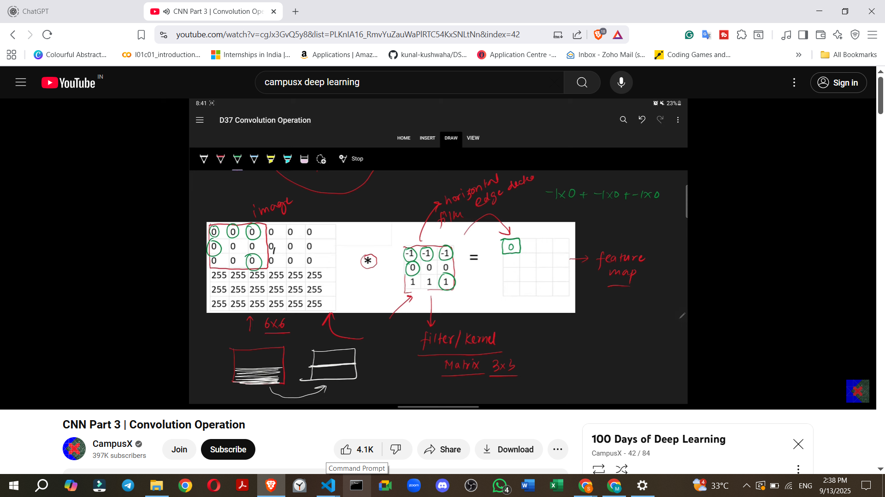

◦ **Second Row of Feature Map**:

▪ The filter moves down. The top row of the filter aligns with a row of 0s. The middle row aligns with a row of 0s. The bottom row aligns with a row of 255s.

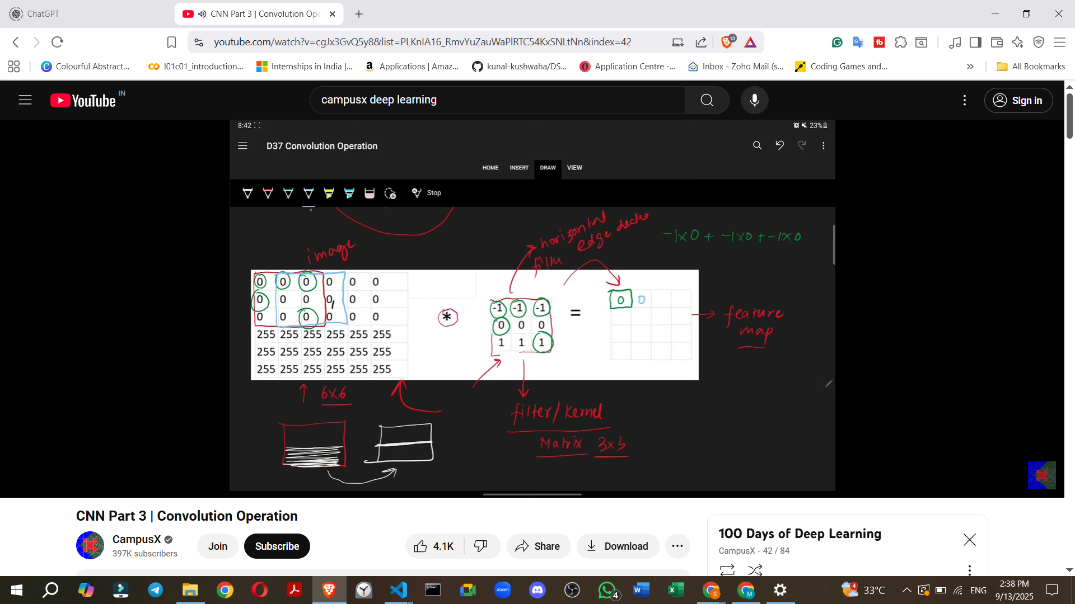

▪ For the first position: (-1*0) + (-1*0) + (-1*0) + (0*0) + (0*0) + (0*0) + (1*255) + (1*255) + (1*255) = **255 + 255 + 255 = 765**. However, the source shows values like 255. This implies the values are clipped or scaled, but the core idea of high activation at the edge is captured. The source states "255 multiplied by 1 is 255" and the result is 255.

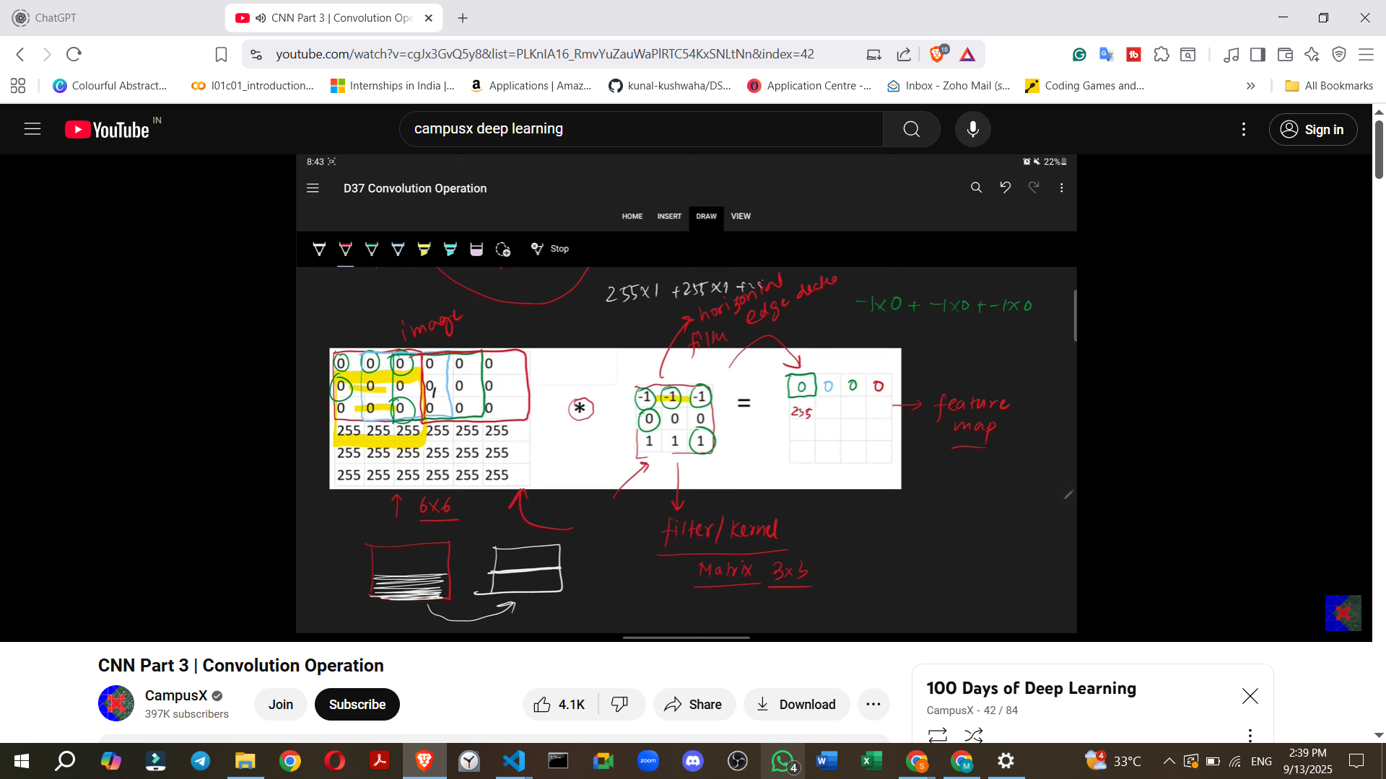

This suggests a simplified output, or a single value is focused on. Let's follow the provided video calculation for the 6x6 image where the output is simply 255 for the middle rows. So, the values will be ****.

◦ **Third Row of Feature Map**:

▪ The filter moves down again. The top row of the filter aligns with 0s. The middle row aligns with 255s. The bottom row aligns with 255s. The calculation proceeds similarly, resulting in ****.

◦ **Fourth Row of Feature Map**:

▪ The filter moves down to cover the last three rows of the image (all 255s).

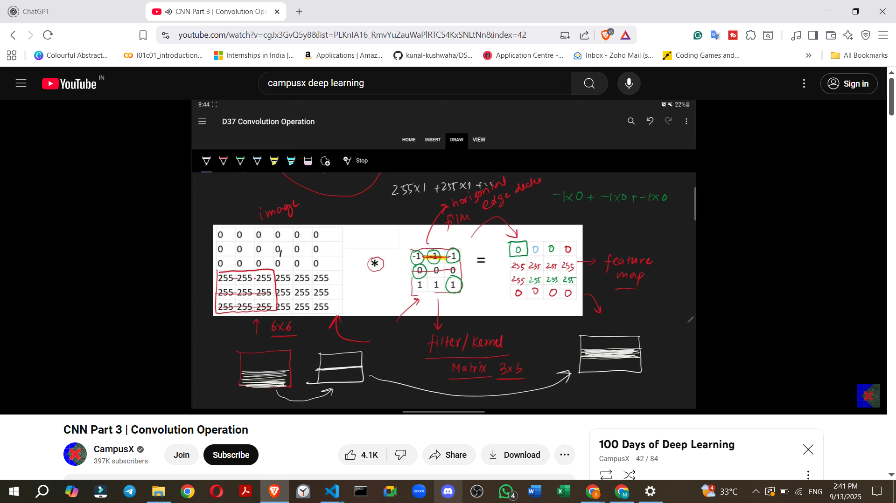

* + **Different Filters:** By changing the values within the filter matrix, different types of features or edges (e.g., vertical, slanted, left, right, top, bottom) can be detected.
* **Learning Filter Values in Deep Learning:**
  + A significant advantage of deep learning is that **you do not need to manually define the filter values**.
  + In a CNN, these filters are initialised with **random values**.
  + During the **training process**, through **backpropagation**, the CNN automatically learns the optimal values for these filters based on the input data and the task. This allows the CNN to create filters on-the-go that are best suited for its specific requirements.

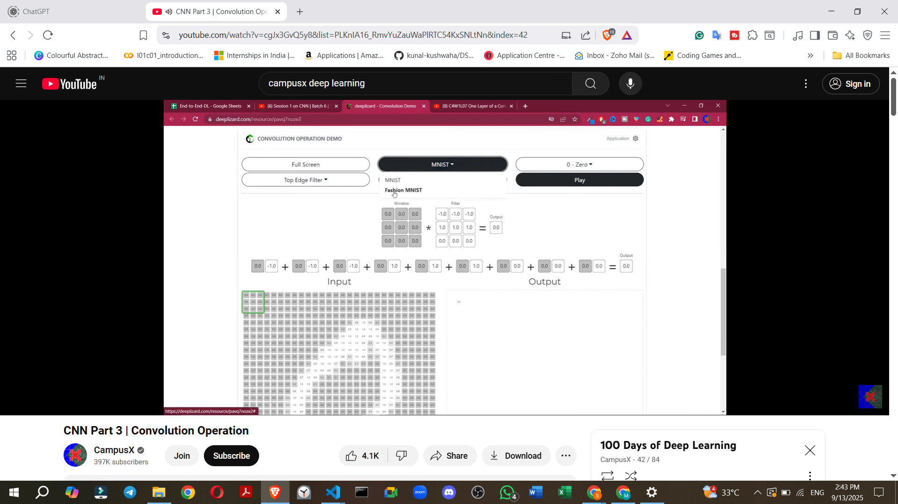

<https://deeplizard.com/resource/pavq7noze2>

**6. Convolution Demo and ReLU Activation**

* A demo involving the MNIST dataset (digits) and predefined filters (top, bottom, right, left edge detectors) illustrates the convolution process.
* The demo shows **item-wise multiplication and addition** as the filter slides across the image.
* **Interpreting Results:**
  + **Positive activations (often shown in red)** indicate that the filter has detected the specific feature it's designed for (e.g., a left edge) with high confidence.
  + **Negative activations (often shown in blue)** indicate the opposite feature (e.g., a right edge when looking for a left edge).
* **Rectified Linear Unit (ReLU):** After the convolution operation, a **ReLU activation function** is typically applied to the feature map.
  + ReLU sets all negative values to zero and keeps positive values as they are.
  + This means if you're looking for left edges, applying ReLU to a feature map (where red indicates left edges and blue indicates right edges) will remove all blue (negative) values, leaving only the detected left edges.

**7. Calculating the Output Feature Map Size**

* For an input image of shape **N x N** and a filter of shape **M x M**, the resulting feature map will have a shape of:
  + **(N - M + 1) x (N - M + 1)**

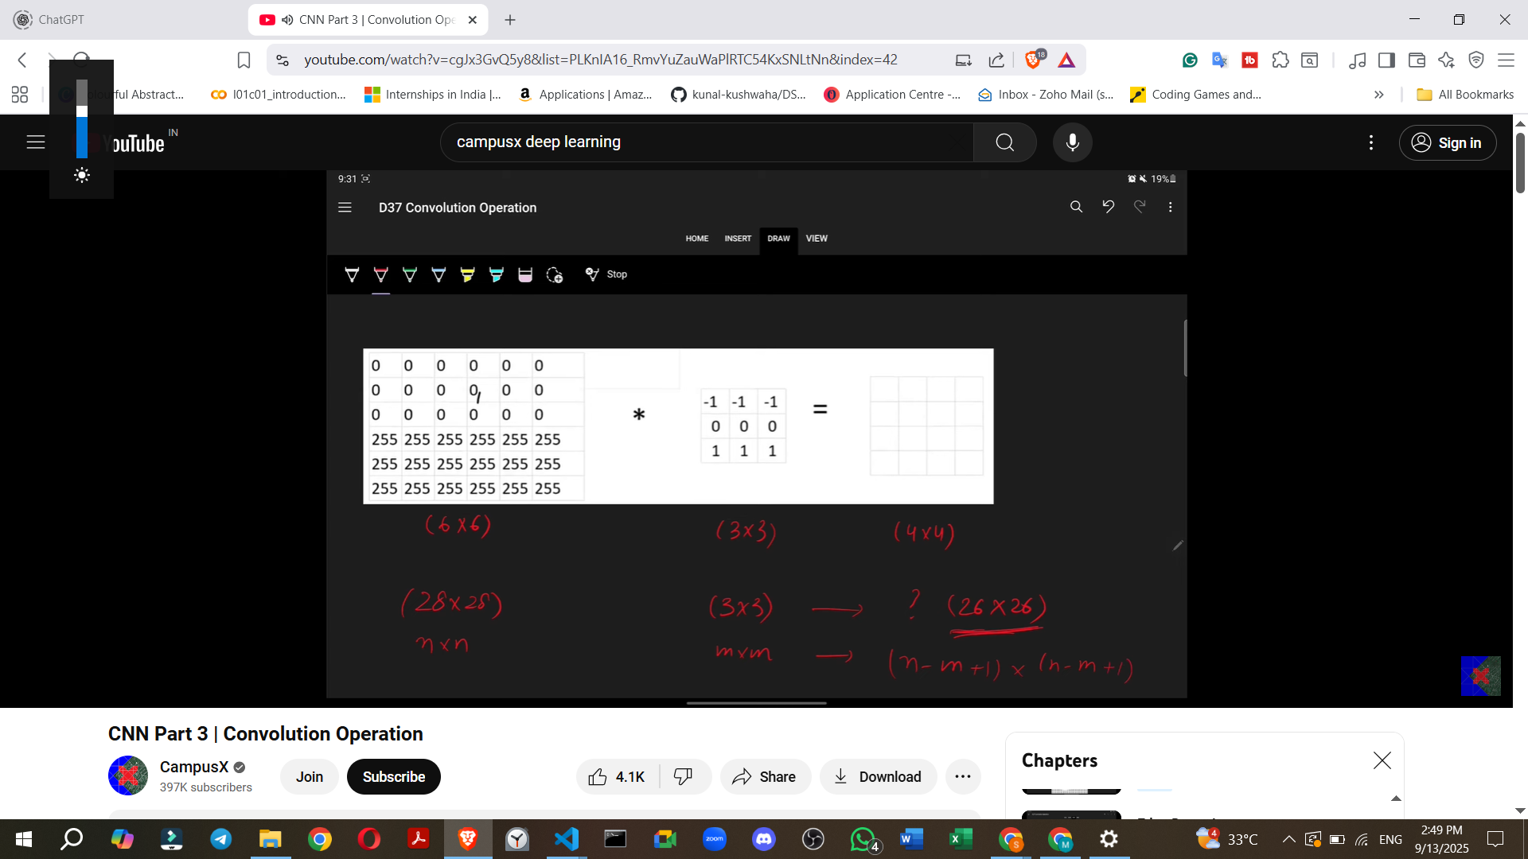

* **Example:** A 6x6 image convolved with a 3x3 filter results in a (6-3+1) x (6-3+1) = **4x4 feature map**.

**8. Convolution with Color (RGB) Images**

* When performing convolution on an RGB (color) image, which has **three channels**, the filter must also have **three channels (depth)**.
* For example, a 3x3 filter for a grayscale image becomes a **3x3x3 filter** for an RGB image.

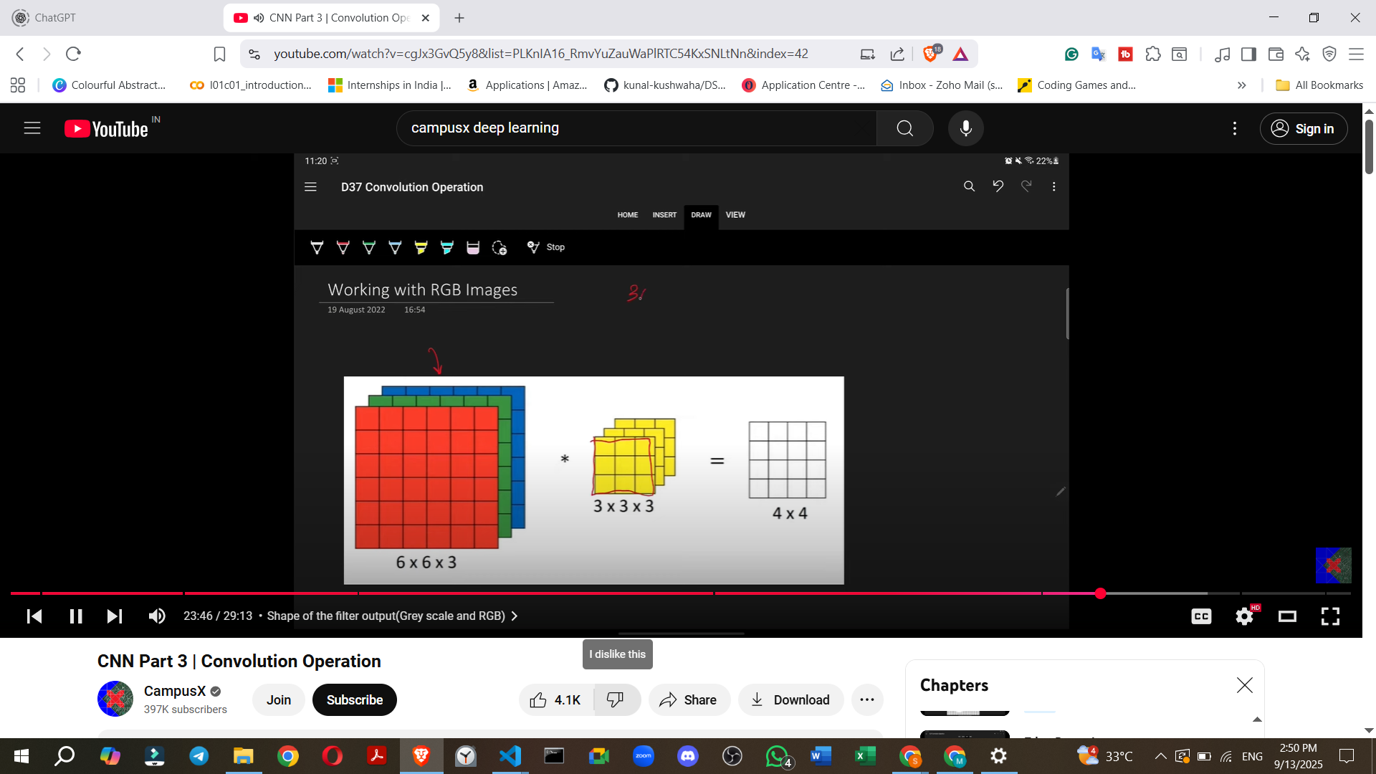

* **Process:** The filter, now a small cuboid, slides over the image (also visualised as a cuboid).
* **Crucial Outcome:** Despite having a multi-channel input image and a multi-channel filter, the convolution operation with a single filter always produces a **single-channel feature map**.
  + This is because the element-wise multiplication happens across all channels of the filter and the image, and then all 27 (for a 3x3x3 filter) resulting numbers are summed up to produce a single value for each position in the output feature map.
* **Formula for multi-channel convolution:** If an image is N x N x C (where C is number of channels) and a filter is M x M x C, the output feature map is (N - M + 1) x (N - M + 1) (single channel).
* 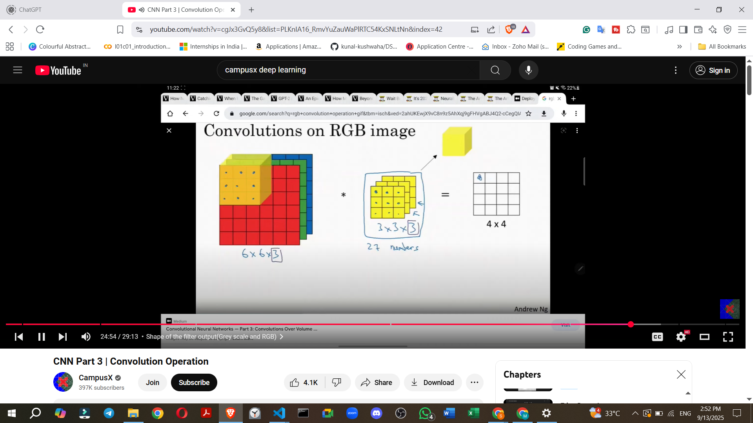
* 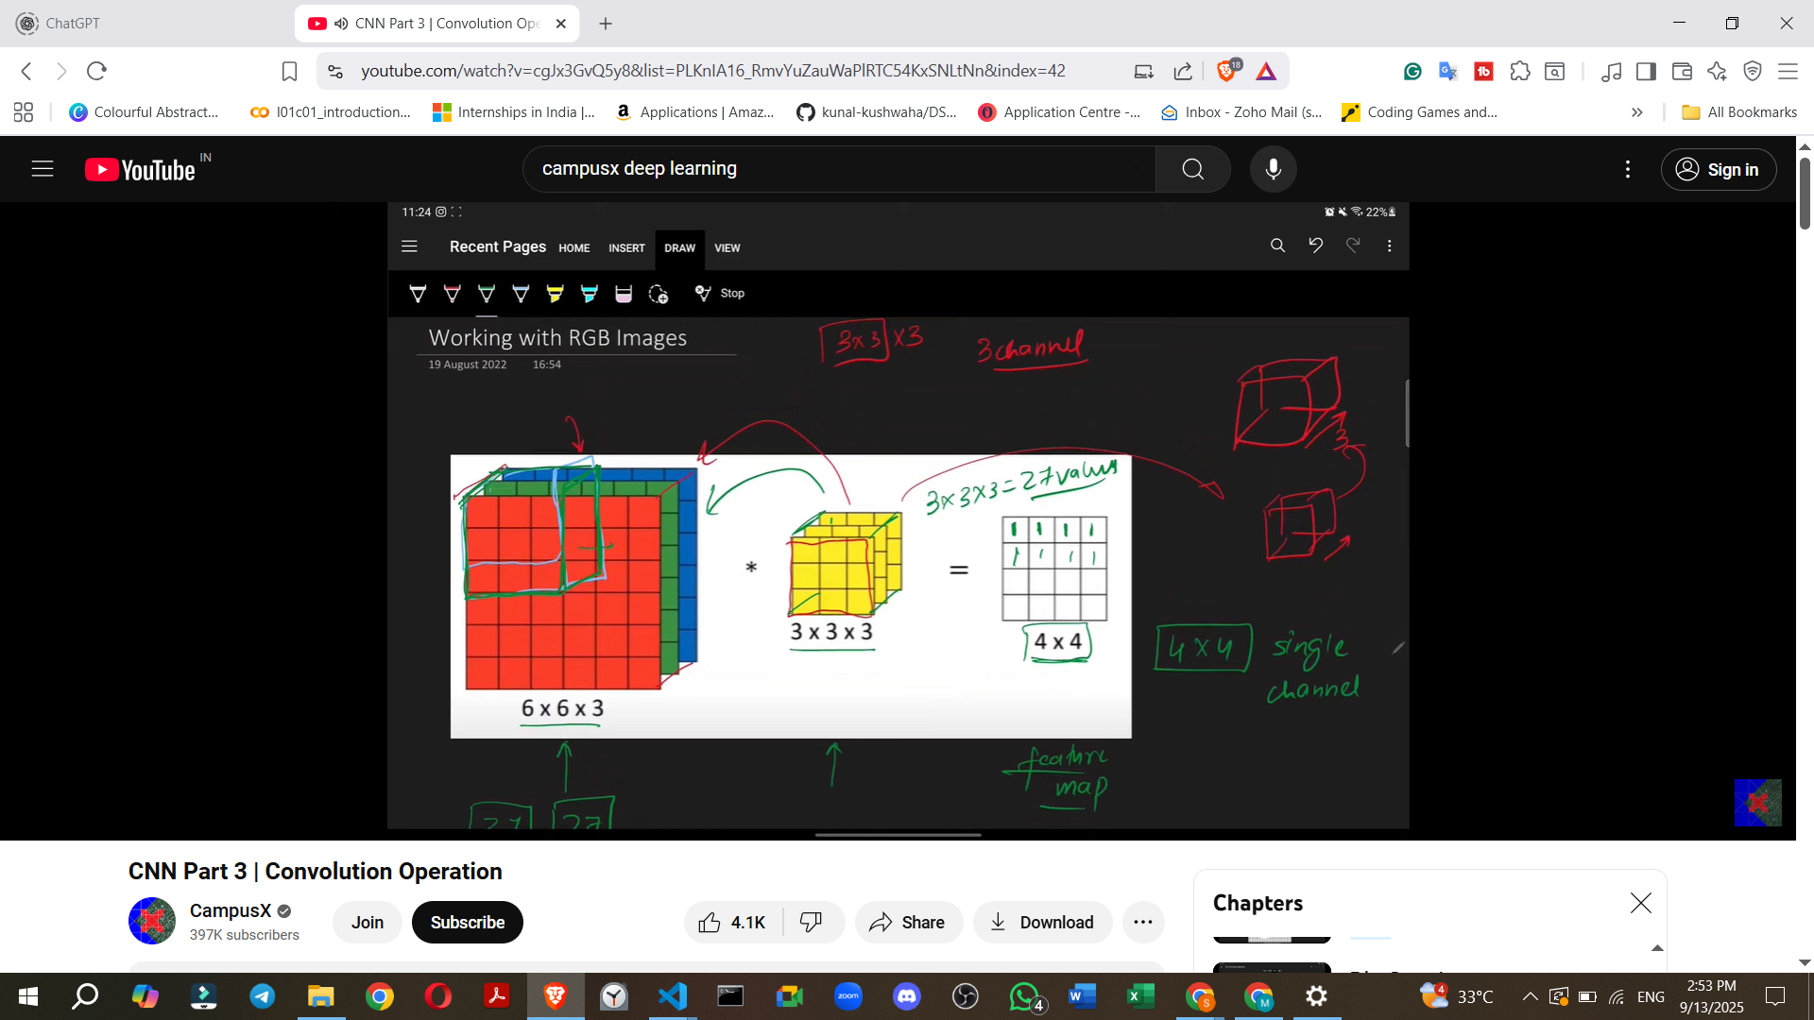
* 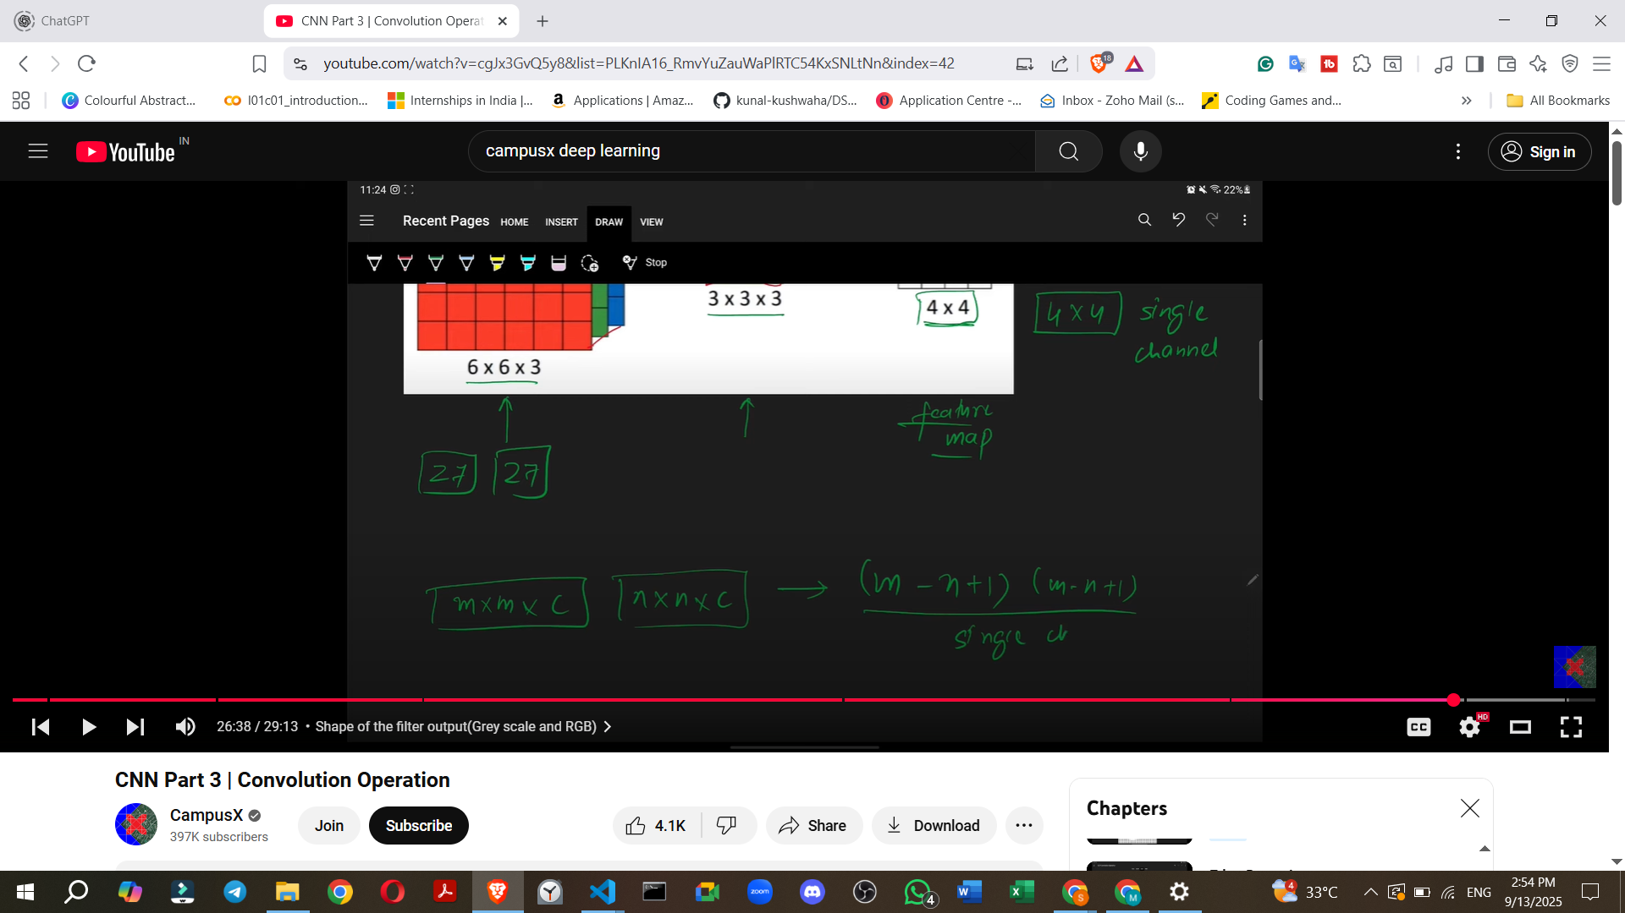

**9. Applying Multiple Filters**

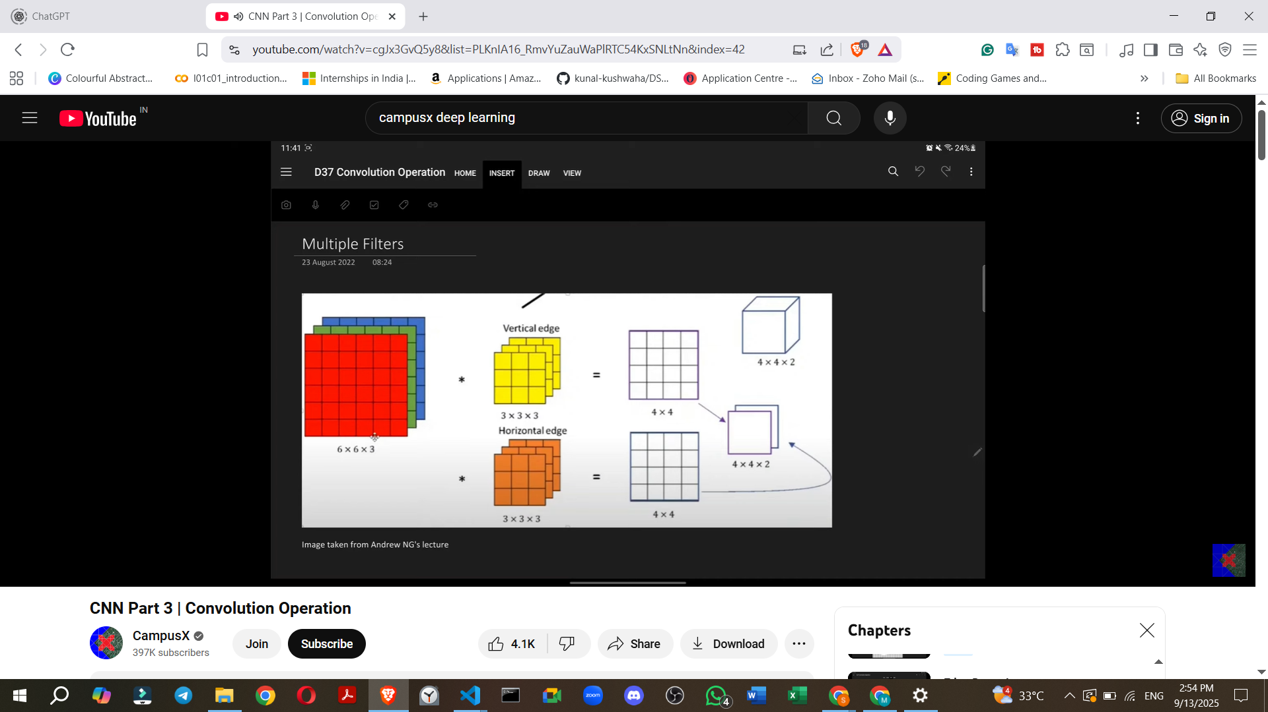

* In practice, a CNN rarely uses just one filter.
* Typically, **multiple filters** are applied to an image.
* Each filter (e.g., one for vertical edges, one for horizontal edges, one for slanted edges) will generate its own **single-channel feature map**.
* These individual feature maps are then **stacked together** to form a **multi-channel output volume**.
* The **number of channels in the output volume will be equal to the number of filters used**.
* **Example:** If two filters are used on a 6x6 image (with 3x3 filters), each will produce a 4x4 feature map. When stacked, the output becomes a **4x4x2 volume**. If 10 filters are used, the output would be 4x4x10. This output then serves as the input for subsequent layers in the CNN.

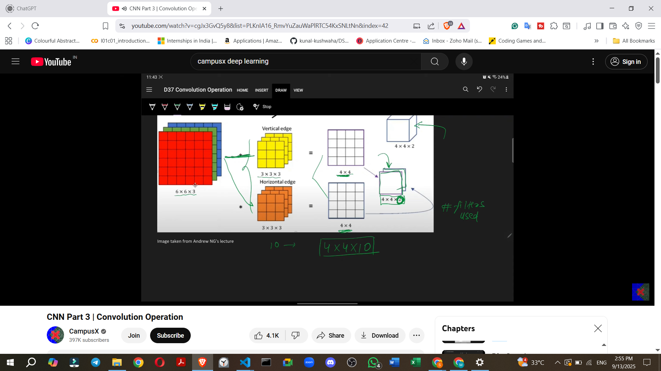

**10. Future Topics**

* Future videos will cover other important concepts such as **strides**, **padding**, and **pooling**, which are also components of CNN architecture. Once these components are understood, they can be combined to build a complete CNN architecture.